Charles Henderson (This is our own work)

Reuel Maddela

Kevin George

Joe Leon

2/22/19

Yi

# Milestone 4

Loom Video:

https://www.useloom.com/share/d0b1346b07c44843874778fad31281f7

WireFrames: 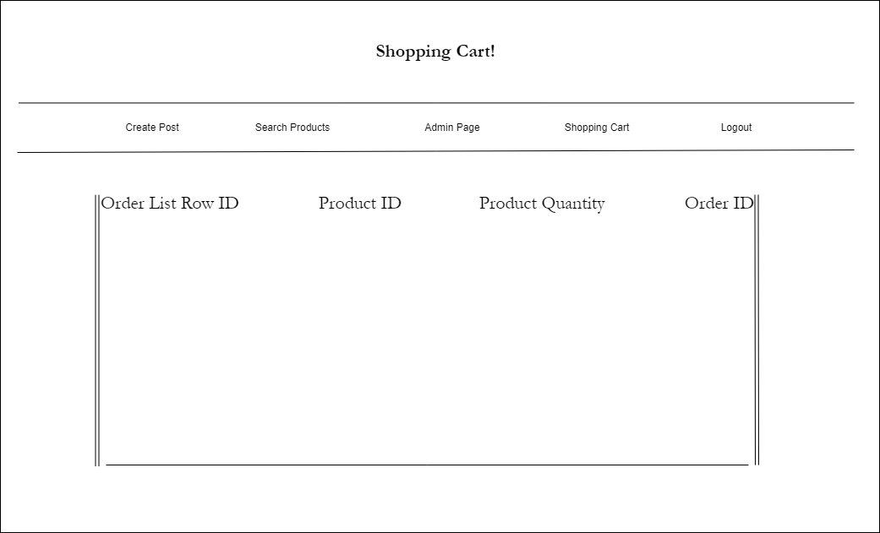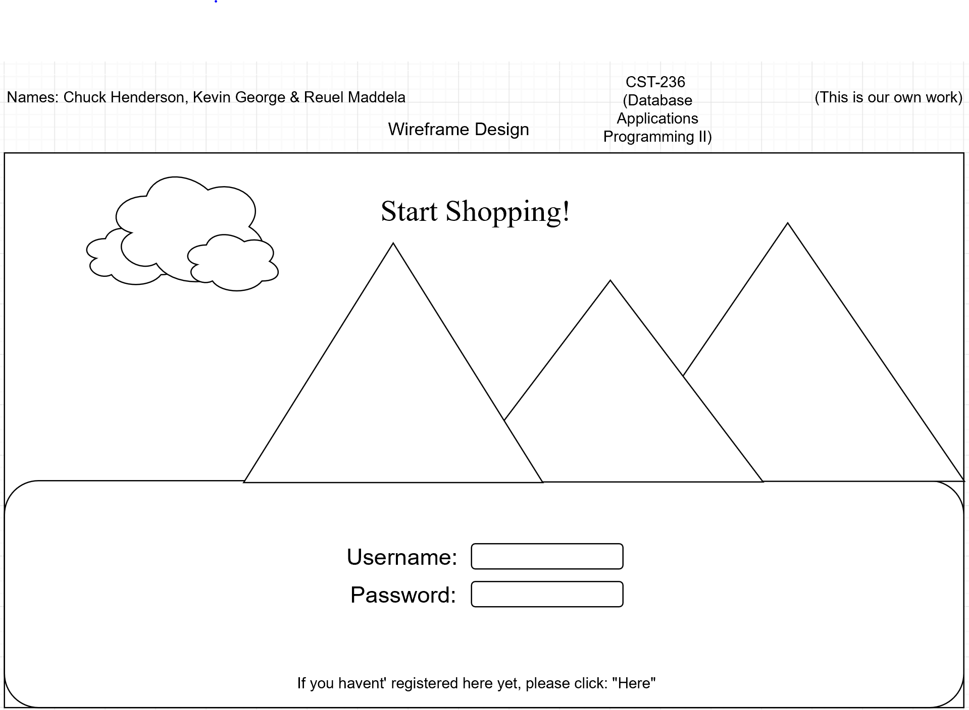

# ER Diagram:

# 

# SQL Script

# 

# UML:

# Link to our application online!

https://demo-php2-cst236.herokuapp.com/

(Username: admin)

(Password: 1234)